Strength Coaching Online Training Schedules
Introduction
Individualised Training Schedules specify the exercises that a client they will use to train, day-by-day, over a period of weeks called a Mesocycle. A Mesocycle is also referred to as a Block.
Inside the Strength Coaching Online web application, clients can access their training schedule from their home page by clicking on the My Training Schedule menu option. This takes them to the set of exercises scheduled by their coach for the current day in their block. Blocks are numbered sequentially for each client and the top tab bar allows clients to view previous and future days in the current block. The <to be determined> option on their home page displays their training history from previous blocks as well as the program that their coach has already scheduled for future blocks.
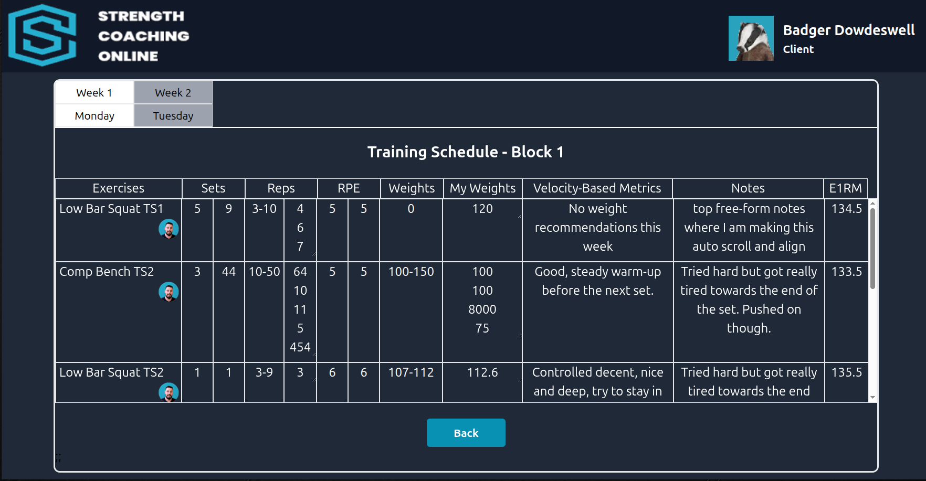
This guide discusses each of the data fields shown in a training schedule, what they mean to clients and coaches, and which ones are used to report their progress. This document should be read in conjunction with the separate Strength Coaching Online Database Design document. Training schedules are stored in the Block, Schedule, and Exercise tables within the Strength Coaching Online PostgreSQL database.

Exercises and reporting progress
Clients can click anywhere in a row in the schedule displayed to access an individual exercise. The Back button on this page returns them to where they were in the list on the previous page.
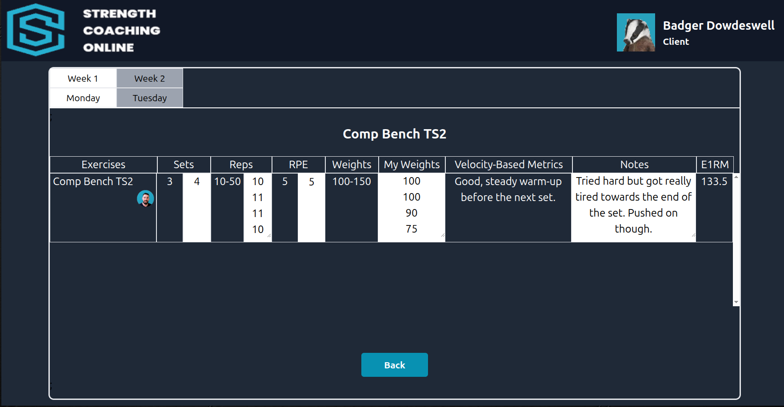
The data fields shown with a black background are instructions from the coach. The fields with a white background can be filled-in and edited by the client to report their progress.

Exercise
The name of the exercise or movement being performed. Clients can click the image below the exercise name to play a video that demonstrates this exercise. Below the video link, other images may also present. These are links to separate feedback videos from the client’s coach. They will appear later after they have completed the exercise and the coach has reviewed the results and any comments the client added to this page.
The exercises are from the Exercise database table. Each record contains the unique exercise_ID key, the description of the exercise, a link to the training video, and some additional free-form notes from the coach. The Schedule record for this exercise contains the exercise_ID as a foreign key to the Exercise table.
Sets
The left hand column is the number of sets for this exercise recommended by the coach. Beside that is a field where the client can enter the number of sets they completed. This is used to let the coach know if the client completed fewer or more sets than was recommended. These are the sets and actual_sets fields from the Schedule table.
Reps
The minimum and maximum number of repeats of each set recommended by the coach. If there no maximum, only the lower number will be displayed. These are the min_reps, max_reps and the array actual_reps from the Schedule table. In the example shown above, the client says they completed four sets, and the number of reps in each set was 10, 11, 11, and then a final 10.
The reps column only accepts numbers. Entries can be separated by either entering a space or a pressing Enter. They can be edited using the arrow, backspace, and delete keys.
RPE
The RPE (Rating of Perceived Exertion) is a measure of difficulty for each set. The range is 1 for low and 10 for high. For exercises with a specified number of reps, the RPE specified by the coach in the left column states the number of repeats the client should have “in the tank” at the end of a set. If the coach specifies 8, that implies that the client should be able to do 2 more reps but not 3. Similarly, an RPE of 7 implies that the client should end the set with 3 reps “in the tank”.
The client enters their own list of perceived RPEs in the column beside the coaches recommendation. Like the reps column, the clients RPE column only accepts numbers. Entries can be separated by either entering a space or a pressing Enter. They can be edited using the arrow, backspace, and delete keys.
Weights
The weights column specifies the lower and upper limits of the range of the metric (usually weight) that is being tracked. This will automatically populate based on the previous weeks entries. If the exercise is a "back down" exercise after a "topset", the topset ER1M will be used to calculate the weight recommendations when the coach is creating your schedule.
My Weights
Clients enter the list of weights they used for each set. If they are performing a body weight exercise, they can enter their body weight. If it is a banded exercise, they leave this blank and enter the band colour in the notes column. (What does the “band colour” look like Luke? Can you please provide an example. )
The column only accepts either integer or decimal numbers. Entries can be separated by either entering a space or a pressing Enter. They can be edited using the arrow, backspace, and delete keys.
Velocity-Based Metrics
This free-form text section is used by the coach to display various velocity metrics if they are being used in the client’s training.
Underneath the coach’s notes, there is room for the client to add their own notes about specific velocity-based metrics they chose to use for this exercise.
Notes
This section is used by the coach to display free-form notes. They may leave instructions here for the client to review when they are completing that week’s training. For example, to remember a certain cue or equipment set up.
Below the coach’s notes, there is another section for the client to add their own notes about a specific exercise. They can use it to record their thoughts for later or to inform the coach about how that exercise went.
E1RM
This is an estimate of the clients Estimated One-Repeat Maximum (E1RM) for the exercise based on that week’s weight used and number of sets completed. This is only a gauge, but will be more accurate if the set was lower than 5 reps and had a higher RPE. For the second week onward, this is weighted to include data from the clients previous few weeks. This provides a more stable estimate that is not as affected by fluctuations in performance.

